Ideation Phase

Define the problem statements

|  |  |
| --- | --- |
| Team ID | 88A47BC9080CDE499E844AF1A08CEE03 |
| Project name | Creating an Sponsored Post for Instagram |

Create a problem statement to understand your customer's point of view. The Customer Problem Statement template helps you focus on what matters to create experiences people will love.

A well-articulated customer problem statement allows you and your team to find the ideal solution for the challenges your customers face. Throughout the process, you’ll also be able to empathize with your customers, which helps you better understand how they perceive your product or service.

Definition of problem diagram

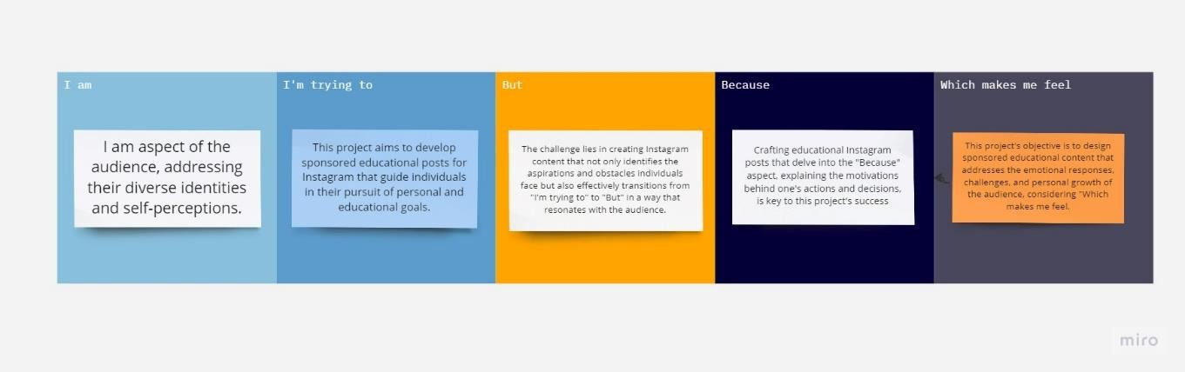

Reference link [:https://miro.com/app/board/uXjVNTAx1GQ=/?share_link_id=538835161111](https://miro.com/app/board/uXjVNTAx1GQ%3D/?share_link_id=538835161111)

|  |  |  |  |  |  |
| --- | --- | --- | --- | --- | --- |
| Problem statement | I am | I’m trying to | But | Because | Which  make me feel |
| PS | he challenge is to create sponsored educational Instagram content that effectively explores the "I am" aspect of the audience, addressing their diverse identities and self- perceptions | This project aims to develop sponsored educational posts for Instagram that guide individuals in their pursuit of personal and educational goals, answering the question of "I'm trying to." | The challenge lies in creating Instagram content that not only identifies the aspirations and obstacles individuals face but also effectively transitions from "I'm trying to" to "But" in a way that resonates with the  audience | Crafting educational Instagram posts that delve into the "Because" aspect, explaining the motivations behind one's actions and decisions, is key to this project's success. | This project's objective is to design sponsored educational content that addresses the emotional responses, challenges, and personal growth of the audience, considering "Which makes me feel." |

Ideation Phase Empathize & Discover

|  |  |  |
| --- | --- | --- |
|  | Team ID | 88A47BC9080CDE499E844AF1A08CEE03 |
|  | Project Name | Creating an Sponsored Post for Instagram |

**Empathy Map Canvas:**

An empathy map is a simple, easy-to-digest visual that captures knowledge about a user’s Behavior and attitudes.

It is a useful tool to helps teams better understand their users.

Creating an effective solution requires understanding the true problem and the person who is experiencing it. The exercise of creating the map helps participants consider things from the user’s perspective along with his or her goals and challenges.

Empathy map

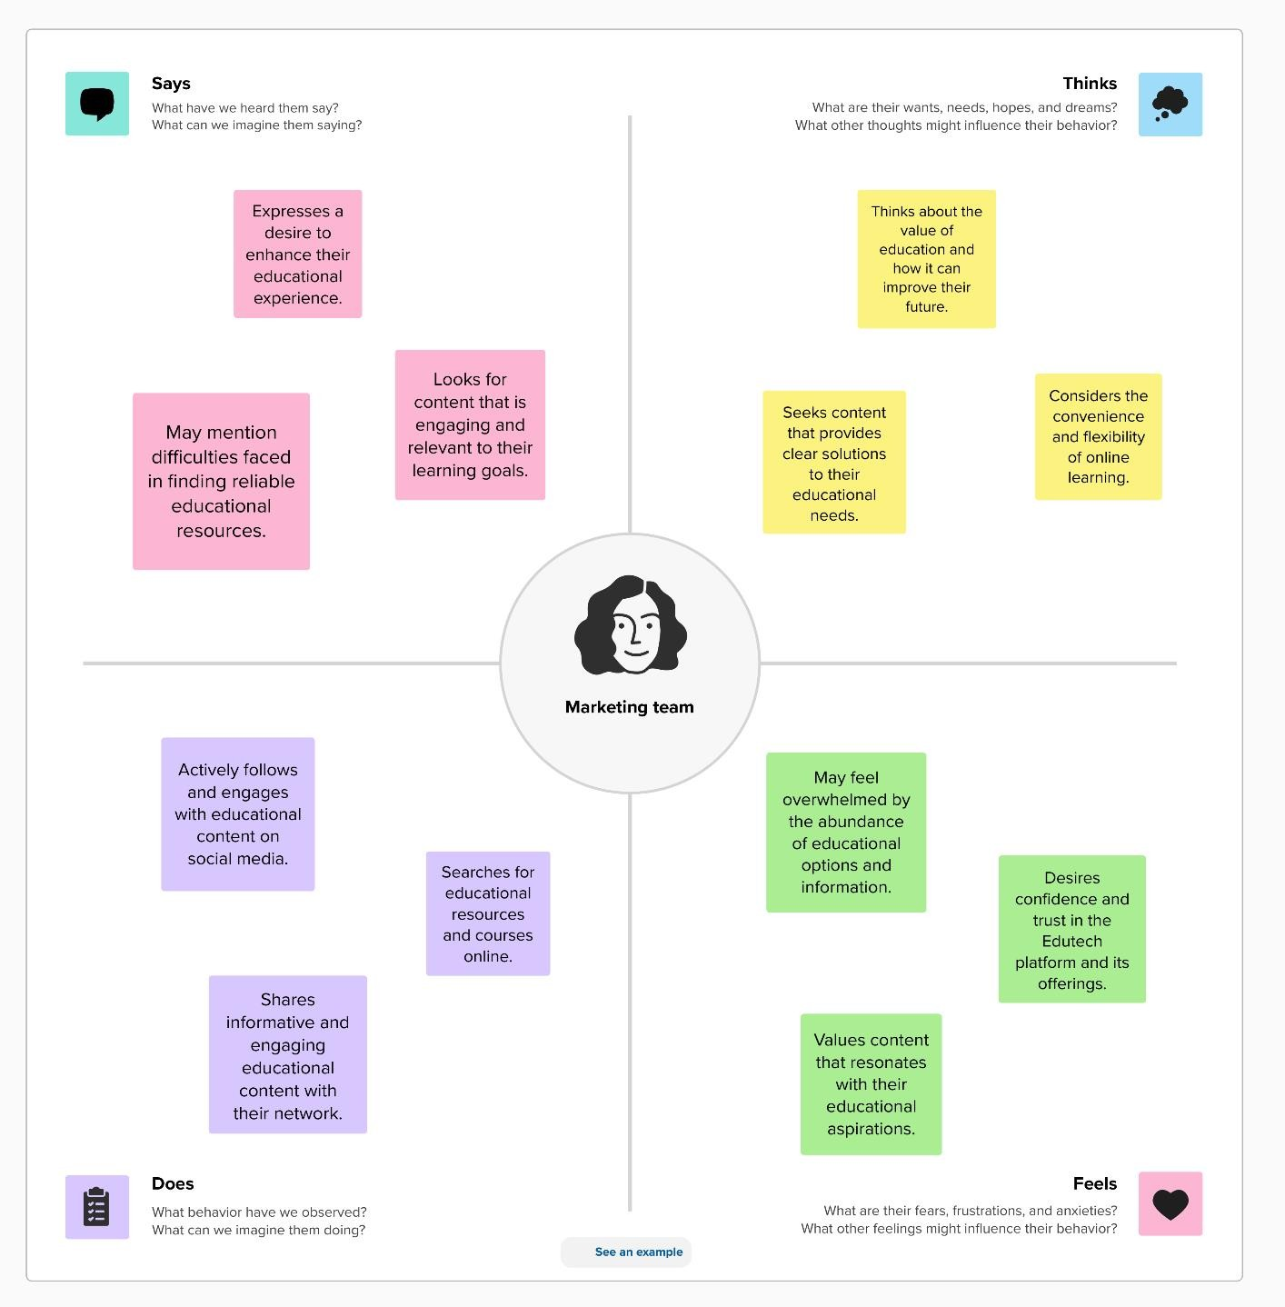

**Reference link:**

[https://app.mural.co/t/creatingansponsoredpostforin4326/m/creatingansp](https://app.mural.co/t/creatingansponsoredpostforin4326/m/creatingansponsoredpostforin4326/1698935664716/6476cf236bd62a2fa3865a8fad5ca6a32f8d26b7?sender=uad13e96a8f26da3893946415) [onsoredpostforin4326/1698935664716/6476cf236bd62a2fa3865a8fad5c](https://app.mural.co/t/creatingansponsoredpostforin4326/m/creatingansponsoredpostforin4326/1698935664716/6476cf236bd62a2fa3865a8fad5ca6a32f8d26b7?sender=uad13e96a8f26da3893946415) [a6a32f8d26b7?sender=uad13e96a8f26da3893946415](https://app.mural.co/t/creatingansponsoredpostforin4326/m/creatingansponsoredpostforin4326/1698935664716/6476cf236bd62a2fa3865a8fad5ca6a32f8d26b7?sender=uad13e96a8f26da3893946415)

Ideation Phase

Brainstorm & Prioritization Template

|  |  |
| --- | --- |
| Team ID | 88A47BC9080CDE499E844AF1A08CEE03 |
| Project Name | Creating an Sponsored Post for Instagram |

**Brainstorm & Idea Prioritization Template:**

Brainstorming provides a free and open environment that encourages everyone within a team to participate in the creative thinking process that leads to problem solving. Prioritizing volume over value, out-of-the-box ideas are welcome and built upon, and all participants are encouraged to collaborate, helping each other develop a rich amount of creative solutions. Use this template in your own brainstorming sessions so your team can unleash their imagination and start shaping concepts even if you're not sitting in the same room.

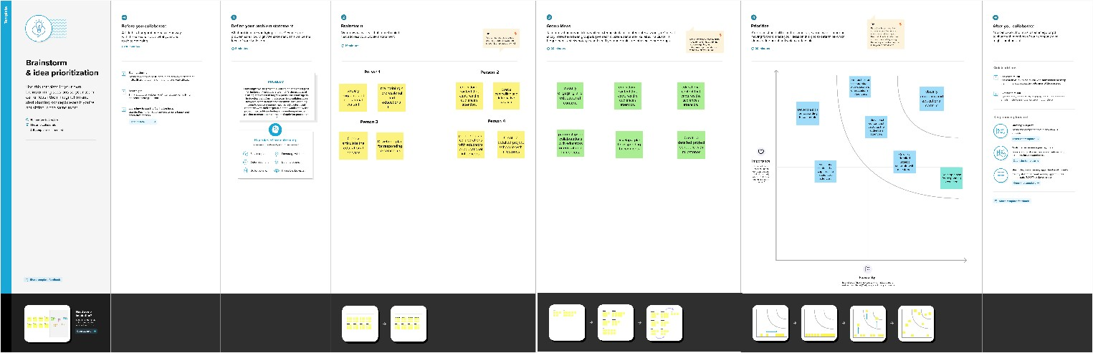

Reference link: [https://app.mural.co/t/creatingansponsoredpostforin4326/m/creatingansponsoredpostforin4326/169](https://app.mural.co/t/creatingansponsoredpostforin4326/m/creatingansponsoredpostforin4326/1698935664716/6476cf236bd62a2fa3865a8fad5ca6a32f8d26b7?sender=uad13e96a8f26da3893946415) [8935664716/6476cf236bd62a2fa3865a8fad5ca6a32f8d26b7?sender=uad13e96a8f26da38939464](https://app.mural.co/t/creatingansponsoredpostforin4326/m/creatingansponsoredpostforin4326/1698935664716/6476cf236bd62a2fa3865a8fad5ca6a32f8d26b7?sender=uad13e96a8f26da3893946415) [15](https://app.mural.co/t/creatingansponsoredpostforin4326/m/creatingansponsoredpostforin4326/1698935664716/6476cf236bd62a2fa3865a8fad5ca6a32f8d26b7?sender=uad13e96a8f26da3893946415)

**Project Design Phase-I Proposed Solution Template**

|  |  |
| --- | --- |
| Team ID | 88A47BC9080CDE499E844AF1A08CEE03 |
| Project Name | Creating an sponsored post for Instagram |

**Proposed Solution Template:**

Project team shall fill the following information in proposed solution template.

|  |  |  |
| --- | --- | --- |
| **S.No.** | **Parameter** | **Description** |
| 1. | Problem Statement (Problem to be solved) | Create an engaging sponsored post for Instagram to promote a new fitness product, targeting young adults. The post should highlight the product's unique features, include relevant hashtags, and encourage user interaction. The goal is to increase brand visibility and drive sales  through compelling visuals and persuasive captions. |
| 2. | Idea/Solution description | Create an engaging sponsored post for Instagram by combining captivating visuals, concise, relatable copy, and strategic use of relevant hashtags. Ensure the content seamlessly integrates the product or service you're promoting, making it feel authentic to your audience. Finally, leverage Instagram's targeted ad options to reach your desired audience for  maximum impact. |
| 3. | Novelty/Uniqueness | Incorporate novelty into your sponsored Instagram post by crafting a creative and relatable story around the product, showcasing its unique features in a fun and unexpected way.  Experiment with fresh visual formats, such as cinema graphs or carousel ads, to capture your audience's attention and stand out in their feeds. By fostering a sense of curiosity and excitement,  your sponsored post will pique interest and drive higher engagement. |
| 4. | Social Impact /Customer Satisfaction | Elevate the impact of your sponsored Instagram post by highlighting the positive change the promoted product or service brings to people's lives or the environment. Share authentic testimonials or stories from satisfied customers to establish trust and credibility, emphasizing how it solves real problems. Encourage user-generated content with a dedicated hashtag to foster a sense of community and customer satisfaction,  fostering a lasting connection with your brand. |
| 5. | Business Model (Revenue Model) | Leverage your sponsored Instagram post to drive revenue by focusing on a performance-based model, tracking conversions and ROI meticulously to ensure the ad spend directly correlates with sales. Consider partnering with influencers who align with your brand to amplify  reach, utilizing their audience to boost revenue |

|  |  |  |
| --- | --- | --- |
|  |  | streams. Implement strategic call-to-action elements and promotional codes to encourage direct purchases and measure the post's contribution to your business model. |
| 6. | Scalability of the Solution | Craft an Instagram sponsored post that emphasizes the scalability of your solution, demonstrating its ability to cater to various customer segments and expand into new markets. Showcase how your product or service can effortlessly adapt to changing demands, offering a sustainable, long-term value to a growing audience. Use compelling visuals and clear messaging to convey the solution's limitless potential and widespread applicability, capturing  the attention of a broad spectrum of potential customers. |

# Project Design Phase-I Solution Architecture

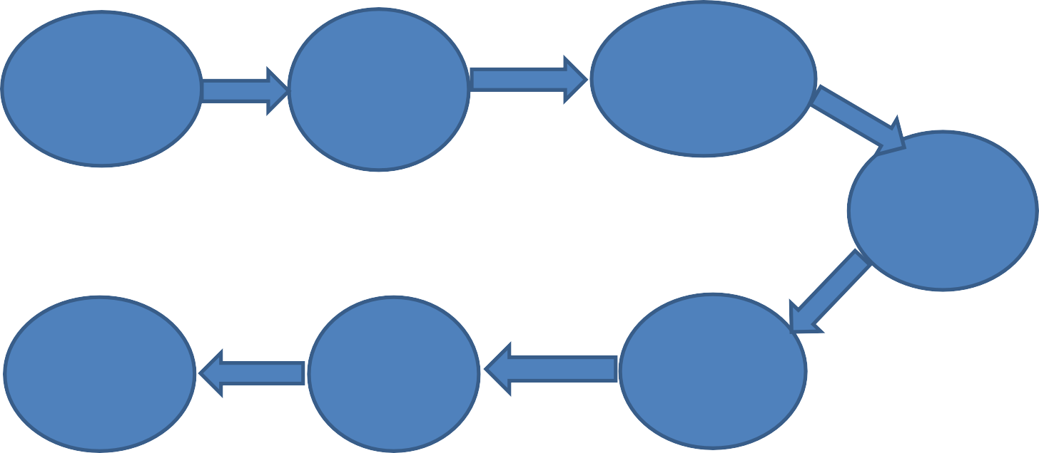

User

Interface(UI)

Canva

Integration

Authentication

and Authorization

Scheduling

and Automation

Security

& Compliance

Analytics

& Reporting

Instagram

API

Integration

|  |  |
| --- | --- |
| **Team ID** | **88A47BC9080CDE499E844AF1A08CEE03** |
| **Project Name** | **Creating an Sponsored post for Instagram** |

**Solution Architecture:**

Solution architecture is a complex process – with many sub-processes – that bridges the gap between business problems and technology solutions. Its goals are to:

* Find the best tech solution to solve existing business problems.
* Describe the structure, characteristics, behavior, and other aspects of the software to project stakeholders.
* Define features, development phases, and solution requirements
* Provide specifications according to which the solution is defined, managed, and delivered. The solution architecture of my project “Creating an Sponsored post for Instagram “ is shown below.

**Flow of a Project:**

The data flow of my project is discussed with step by step process as below.

**step-1: User Interface (UI):**

Develop a user-friendly web interface where administrators can create sponsored Instagram posts. Include options for adding content, captions, images, and scheduling.

**Step-2: Canva Integration:**

Integrate Canva's design features, allowing users to create visually appealing posts. Provide access to Canva's templates, elements, and design tools.

**Step-3: Authentication and Authorization:**

Implement user authentication for secure access to the platform. Implement automation for posting at specified times.

**Step-4: Scheduling and Automation:**

Create a scheduling system to determine when posts should be published on Instagram. Implement automation for posting at specified times

**Step-5: Instagram API Integration:**

Connect to the Instagram API to facilitate post publishing. Enable user authentication for the Instagram account linked to the education platform.

**Step-6: Analytics and Reporting:**

Implement tracking and analytics tools to monitor post performance. Gather data on engagement, reach, and conversions for campaign assessment

**Step 7 : Security and Compliance:**

Ensure data security through encryption, access controls, and security audits. Adhere to Instagram and Canva's policies and guidelines for sponsored posts and API usage.

These are the Flow of our project ” **Creating an sponsored Post For Instagram** ” and its step-by step procedure is described briefly with Solution architecture in the above content.

**Project Design Phase-II**

**Solution Requirements (Functional &Non-functional)**

|  |  |
| --- | --- |
| Team ID | 88A47BC9080CDE499E844AF1A08CEE03 |
| Project Name | Creating an sponsored post for Instagram |

**Functional Requirements:**

Following are the functional requirement so the proposed solution.

|  |  |  |
| --- | --- | --- |
| **FR No.** | **Functional Requirement(Epic)** | **Sub Requirement(Story/Sub-Task)** |
| FR-1 | **User authentication requirement** | User authentication is essential for creating a sponsor post on Instagram to verify the identity of the account holder. It helps maintain the credibility of sponsored content and ensures that the post adheres to Instagram's advertising policies. By authenticating users, Instagram aims to provide a transparent and  trustworthy platform for sponsored posts. |
| FR-2 | **Mobile accessibility requirement** | Ensuring that users with disabilities can access and engage with the content. Involves optimizing post content, descriptions, and user interfaces for screen readers and other assistive technologies on mobile devices. |
| FR-3 | **Notification requirement** | Crucial to inform users that the content is a paid promotion. Us toing labels like "Sponsored," "Ad," or "Paid partnership" meet Instagram's advertising standards. These notifications enhance trust and help users distinguish between organic and sponsored content  on the platform. |
| FR-4 | **Reporting requirement** | Accurate and timely submission of campaign performance data to the platform. Allowing Instagram and advertisers to evaluate the effectiveness of the campaign. To measure the success of sponsored content and ensure transparency between advertisers and the  platform. |
| FR-5 | **Data export requirement** | Provides advertisers with the means to access and export campaign-related data, facilitating performance analysis and reporting. This ensures transparency and empowers advertisers to make  informed decisions about their Instagram campaigns. |
| FR-6 | **Feedback requirements** | It soliciting and addressing user feedback, enhancing the overall quality of sponsored content, and maintaining a positive user experience on the platform. This iterative feedback process contributes to more effective and  engaging sponsored posts. |

**Non-functional Requirements:**

Following are the non-functional requirements of the proposed solution.

|  |  |  |
| --- | --- | --- |
| **FR No.** | **Non-Functional Requirement** | **Description** |

|  |  |  |
| --- | --- | --- |
| NFR-1 | **Usability** | It ensures that advertisers can easily navigate the platform, target their audience, and manage campaigns effectively,  User-friendly interface is key to optimizing the  usability of Instagram's sponsored post creation process. |
| NFR-2 | **Security** | safeguarding user data, and preventing potential breaches crucial for maintaining trust and privacy on the platform.  Robust security measures protect advertisers and users alike, underlining Instagram's commitment to a secure advertising environment. |
| NFR-3 | **Reliability** | It guarantees that advertisers can consistently publish content and reach their target Dependable platform supports advertisers in  achieving their marketing objectives and  maintaining a consistent presence for their  sponsored content. |
| NFR-4 | **Performance** | Optimize content for engagement and target audience to maximize the impact of your sponsored post on Instagram.  Monitor key metrics like reach, engagement, and click-through rates to fine-tune your sponsored post's performance over time. |
| NFR-5 | **Availability** | Sponsored posts on Instagram are available to businesses and creators through Instagram's advertising platform.  You can easily set up and launch sponsored posts to reach a wider audience and achieve your marketing goals on the platform. |
| NFR-6 | **Scalability** | Instagram's sponsored post feature offers scalability, allowing businesses to reach a broad or niche audience based on their budget and goals.  . With options for customizable budgets and targeting, you can scale your sponsored posts to meet the specific needs of your marketing campaign. |

User Authentication and Post Creation , Post

User Profile Data Sponsored Post Content

Data stores

Processes

**Project Design Phase-II**

**Data Flow Diagram & User Stories**

|  |  |
| --- | --- |
| Team ID | 88A47BC9080CDE499E844AF1A08CEE03 |
| Project Name | Creating an sponsored post for Instagram |

**Data Flow Diagrams:**

A Data Flow Diagram (DFD) is a traditional visual representation of the information flows within a system. A neat and clear DFD can depict the right amount of the system requirement graphically. It shows how data enters and leaves the system, what changes the information, and where data is

stored.

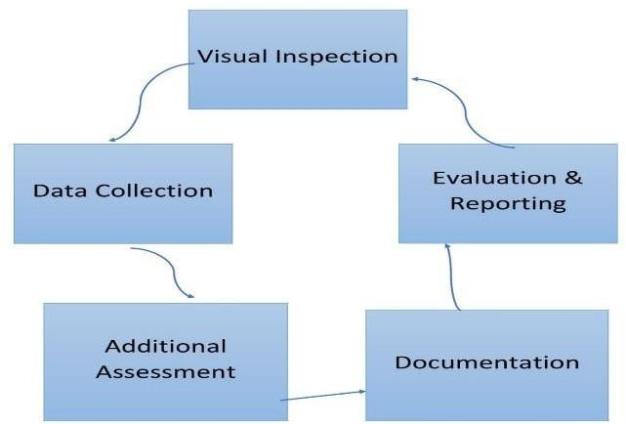**Example:** [**(Simplified)**](https://developer.ibm.com/patterns/visualize-unstructured-text/)

Instagram User, Advertiser

External Entities

Example: Data Flow Diagram

Data Flows

Post content is sent for review

|  |  |  |  |  |  |  |
| --- | --- | --- | --- | --- | --- | --- |
| **User Type** | **Functional Requirement (Epic)** | **User Story Number** | **User Story / Task** | **Acceptance criteria** | **Priority** | **Team Member** |
| Content Creators | User Registration & profiles | USN-1 | As a user I Click the "Sign Up" button on the platform's homepage and fill in your full name, email, and a secure password. | I can Ensure that the user registration process collects essential information such as name, email, and  password. | High | Suruthi |
|  |  | USN-2 | As a user I Confirm that you receive and click the verification link in the email sent to you for email confirmation.. | I can Implement email verification to confirm the authenticity of registered  users | High | Sowmiya |
|  |  | USN-3 | As a user, I Log in using your registered email and password to access the platform's collaboration tools for sponsored content  creation using canva. | I can Enable users to provide optional profile details, like profile picture  and a brief bio | Medium | Sneha |
|  |  | USN-4 | As a city residient,I Enhance your user profile with additional information to get started with creating and collaborating on engaging sponsored Instagram posts.. | Verify that registered users can successfully create and manage sponsored posts for Instagram within the project's  interface | Medium | Sathiyapriya |
|  | Content creation & collaboration | USN-5 | Influencers and brands can collaborate on sponsored posts, including negotiation and agreement functionalities | I can create Content creation tools must allow for easy image and caption creation, with seamless collaboration options  among team members | High | Suruthi |
|  | Sponsored post creation | USN-6 | As a user ,I should be able to create, customize, and schedule sponsored posts with captions, images, and tags. | Sponsored post creation should offer  customization options for visuals and captions, ensuring alignment with  brand guidelines. | High | Sowmiya |
| Social media Manager | Advertising | USN-7 | As a social media manager, I aim to craft an Instagram sponsored post to boost our project's visibility and engagement among our target audience. This post will feature captivating visuals and a persuasive caption in alignment with our project's goals and  brand identity. | Advertisements within the project must target the intended audience demographics and interests effectively. | Low | Sneha |

|  |  |  |  |  |  |  |
| --- | --- | --- | --- | --- | --- | --- |
|  |  | USN-8 | As a user I Create an Instagram sponsored post for our project to enhance audience reach and engagement, aligning with our project's identity and goals. | The project should provide detailed analytics to assess the performance and ROI of sponsored Instagram posts, enabling data-driven  decision-making | Medium | Sathiyapriya |
| Digital Marketer | User Registration | USN-9 | As a user I Click the "Sign Up" button on the platform's homepage and fill in your full name, email, and a secure password. | I can Ensure that the user registration process collects essential information such  as name, email, and password. | Low | Suruthi |
|  | Sponsored post creation | USN-10 | As a user ,I should be able to create, customize, and schedule sponsored posts with captions, images, and tags | Sponsored post creation should offer customization options for visuals and captions, ensuring  alignment with brand guidelines. | High | Sowmiya |
| Administrator | Maintenance | USN-11 | As a administrator I can maintain all the activities of the website. | Administrator must maintain all activities of both the all performance. | Medium | Sneha |

**Project Design Phase-II TechnologyStack(Architecture&Stack)**

|  |  |
| --- | --- |
| TeamID | 88A47BC9080CDE499E844AF1A08CEE03 |
| ProjectName | creating an sponsored post for instagram |

**Technical Architecture:**

TheDeliverableshallincludethearchitecturaldiagramasbelowandtheinformationasperthetable1&table2

User Interface

Authentication & Authorization

Image & Video Processing

Content Management System

Notification System

Database

Instagram API Integration

Scheduling & posting

Analytics & Reporting

Error Handling

Third party Services

Security Measures

**Table-1:Components&Technologies:**

|  |  |  |  |
| --- | --- | --- | --- |
| **S.No** | **Component** | **Description** | **Technology** |
| 1. | User Authentication | Allows users to securely log in using Instagram credentials. | OAuth 2.0 for Instagram API. |
| 2 | Content Management System (CMS) | Provides tools for users to create and manage sponsored post content. | Custom CMS using Django (Python) for backend and React (JavaScript) for the  frontend. |
| 3. | Media Storage | Stores images and videos associated with posts. | Google |
| 4. | Campaign Management | Manages sponsored campaigns, scheduling, and budget allocation. | SQL |
| 5. | Ad Targeting Engine | Utilizes machine learning algorithms to target the right audience for sponsored posts. | Machine learning |
| 6. | Payment Gateway | Handles secure payment transactions for advertisers. | Stripe, Pay PaL |
| 7. | Analytics and Insights | Provides data and insights on post performance. | Data analytics |
| 8. | Push Notifications | Sends notifications to users for updates, likes, and comments. | Firebase Cloud Messaging |
| 9. | Content Delivery Network (CDN) | Ensures fast and reliable delivery of media content to end-users. | CDN services like Akamai or Cloudflare. |
| 10. | Security and Privacy Measures | Implements security features and ensures user data privacy. | SSL/TLS for data encryption, access controls, and security best practices. |

|  |  |  |  |
| --- | --- | --- | --- |
| 11. | Monitoring and Scaling | Monitors system performance and scales resources as needed to handle increased traffic. | Tools like Prometheus for monitoring and Kubernetes for resource  orchestration. |

**Table-2:ApplicationCharacteristics:**

|  |  |  |  |
| --- | --- | --- | --- |
| **S.No** | **Characteristics** | **Description** | **Technology** |
| 1. | User-Friendly Interface | The application should have an intuitive and user- friendly interface to ensure that users can easily navigate and create sponsored posts without any difficulty | Use responsive web design and mobile app development technologies like React Native or Flutter for a seamless user experience on both web and  mobile platform |
| 2. | Content Scheduling and Automation | This feature allows users to schedule sponsored posts in advance, automate posting, and target specific audiences at the optimal times. | Implement an API integration with the Instagram Graph API or third-party social media management tools for post  scheduling and automation. |
| 3. | Data Analytics and Performance Tracking | The application should provide users with insights into the performance of their sponsored posts, including engagement metrics, reach, and conversion rates. | Utilize data analytics tools and libraries like Google Analytics and social media analytics APIs to collect and present  performance data. |
| 4. | Secure Account Authentication | Ensure secure authentication and authorization methods to protect user accounts and sensitive data while connecting to Instagram for post creation | Implement OAuth 2.0 for secure user authentication and authorization when linking Instagram accounts to the  application |

Project Design Phase-**||**

# OPEN SOURCE FRAMEWORKS

|  |  |
| --- | --- |
| TEAM LEAD | V.SURUTHI |
| NM ID | 88A47BC9080CDE499E844AF1A08CEE03 |
| PROJECT NAME | Creating an Sponsored Post for Instagram |

**Introduction:**

* Briefly explain the concept of sponsored posts on Instagram.
* Introduce the idea of using open-source frameworks to improve sponsored content creation.

# Section 1: Choosing the Right Image:

* Discuss the importance of selecting an eye-catching and relevant image.
* Suggest open-source image editing tools like GIMP and Inkscape for image enhancements.
* Explain how these tools can be used for basic image editing, filters, and effects.

# Section 2: Crafting Engaging Captions:

* Emphasize the role of compelling captions in driving user engagement.
* Showcase open-source text editors like LibreOffice Writer or even simple text editors.
* Provide tips on crafting captivating captions, such as storytelling and using relevant hashtags.

# Section 3: Hashtag Research:

* Explain the significance of using the right hashtags to increase post visibility.
* Introduce open-source hashtag research tools like "Hashtagify" for finding trending hashtags.
* Share tips on selecting and using relevant hashtags effectively.

# Section 4: Scheduling and Automation:

* Discuss the importance of posting at the right times.
* Suggest open-source social media management tools like "SocialBee" or "Crowdfire" for scheduling posts.
* Explain how these tools can help automate posting and optimize engagement.

# Section 5: Measuring and Analyzing Engagement:

* Highlight the need for tracking post performance.
* Recommend open-source analytics tools like "Matomo" for Instagram insights.
* Explain how these tools can help you analyze likes, comments, shares, and other key metrics.

# Section 6: Compliance and Disclosure:

* Stress the importance of complying with Instagram's sponsored content guidelines.
* Provide open-source templates for disclosure statements to maintain transparency with your audience.

Project Design Phase-**|| Third-Party API’s**

|  |  |
| --- | --- |
| TEAM LEAD | V.SURUTHI |
| NM ID | 88A47BC9080CDE499E844AF1A08CEE03 |
| PROJECT NAME | Creating an sponsored post for Instagram |

Creating a sponsored post for Instagram using a third-party API involves several steps. Here's a high-level overview of the process:

# Set up Your Instagram Business Account:

To create sponsored posts on Instagram, you'll need to have a business or creator account. If you don't already have one, you can switch from a personal account to a business account in your Instagram settings.

# Identify the Third-Party API:

Choose a third-party API that offers the functionality you need for creating and managing Instagram sponsored posts. Some popular options include Hootsuite, Buffer, or the Facebook Graph API (since Facebook owns Instagram).

# Authenticate Your Account:

Most third-party APIs will require you to connect your Instagram business account to their platform. This typically involves authentication through OAuth or similar mechanisms. Follow the API's documentation for this step.

# Create the Sponsored Post Content:

Depending on the API you choose, you might have access to features for creating visually appealing Instagram posts. You can usually upload images, videos, captions, hashtags, and other elements. Make sure your content aligns with your campaign goals and Instagram's guidelines.

# Schedule or Publish the Post:

Most third-party APIs allow you to schedule your sponsored post to be published at a specific time or publish it immediately. Follow the API's instructions to set the post's timing.

# Engagement Tracking:

After the sponsored post is live, the API might offer features to track engagement metrics, such as likes, comments, shares, and reach. Use these insights to gauge the post's performance and make adjustments to your campaign if necessary.

# Compliance and Disclosure:

Ensure that your sponsored post complies with Instagram's advertising policies and that you provide proper disclosure if the post is a paid partnership. Failing to do so can result in your post being taken down or legal issues.

# Monitoring and Optimization:

Continuously monitor the performance of your sponsored post and make data-driven decisions to optimize your campaign. Many third- party APIs provide analytics and reporting tools to help with this.

Project Design Phase-**|| CLOUD DEPLOYMENT**

|  |  |
| --- | --- |
| TEAM LEAD | V.SURUTHI |
| NM ID | 88A47BC9080CDE499E844AF1A08CEE03 |
| PROJECT NAME | Creating an sponsored post for Instagram |

# Introduction:

* Provide an overview of the project, which involves creating a sponsored post for Instagram.
* Explain the significance of cloud deployment in ensuring content delivery and scalability.
* Set the stage for the content by highlighting the benefits of utilizing cloud services.

# Section 1: The Role of Cloud Deployment in Instagram Sponsored Posts:

* Explain why cloud deployment is crucial for handling the technical aspects of your campaign.
* Discuss how cloud services provide scalability, reliability, and flexibility.
* Introduce key cloud providers such as AWS, Google Cloud, and Azure.

# Section 2: Content Creation and Storage in the Cloud:

* Describe how cloud storage services like Amazon S3 or Google Cloud Storage can be used to store high-quality images and videos.
* Emphasize the importance of ensuring that your content is easily accessible and load times are minimal.
* Provide guidance on uploading, organizing, and managing content in the cloud.

# Section 3: Content Delivery and Scalability:

* Explain how Content Delivery Networks (CDNs) like Amazon

CloudFront or Google Cloud CDN can accelerate content delivery to users.

* Discuss the scalability and distribution benefits of CDNs in reaching a global audience.
* Share best practices for configuring CDNs for Instagram content.

# Section 4: Serverless Computing and Automation:

* Introduce serverless computing platforms like AWS Lambda or Google Cloud Functions for automated tasks.
* Highlight the potential of serverless for handling background processes, such as resizing images or processing data.
* Provide examples of serverless functions tailored to Instagram content.

# Section 5: Analytics and Insights in the Cloud:

* Discuss how cloud-based analytics services like Google Analytics and AWS QuickSight can help track the performance of your sponsored post.
* Explain the importance of gathering insights to measure the impact of your campaign.
* Share tips on setting up analytics for Instagram posts.

# Section 6: Security and Compliance in the Cloud:

* Address the importance of data security and user privacy in sponsored posts.
* Explain how cloud providers offer tools for securing data and complying with regulations.
* Provide guidance on securing your content in the cloud.

# Conclusion:

* Summarize the benefits of leveraging cloud deployment for Instagram sponsored posts.
* Highlight the efficiency, scalability, and data-driven advantages of using cloud services.
* Encourage businesses and content creators to explore cloud solutions for their campaigns.

Project Development Phase

# No. Of Functional Features Included In The Solution

|  |  |
| --- | --- |
| TEAM LEAD | V.SURUTHI |
| NM ID | 88A47BC9080CDE499E844AF1A08CEE03 |
| PROJECT NAME | Creating an Sponsored Post for Instagram |

Creating a sponsored post for Instagram involves several functional features and components to effectively execute a successful campaign. Here are some of the key functional features along with descriptions.

1. **Content Creation:** This feature involves creating visually appealing and engaging content for the sponsored post. This can include high-quality images, videos, or graphics that align with the brand's message and target audience.
2. **Caption and Hashtags:** Crafting a compelling caption and including relevant hashtags is essential for increasing the reach and engagement of the post. The caption should be concise, on-brand, and provide context to the content.
3. **Scheduling:** This feature allows you to schedule the sponsored post for a specific date and time when your target audience is most active on Instagram. This ensures maximum visibility and

engagement.

1. **Audience Targeting:** Instagram provides tools to define your target audience based on demographics, interests, and behaviors. Accurate audience targeting is crucial for reaching the right people.
2. **Budgeting and Bidding:** This feature allows you to set a budget for your sponsored post campaign and choose the bidding strategy, such as cost-per-click (CPC) or cost-per-impression (CPM).
3. **Analytics and Insights:** Tracking the performance of your sponsored post is vital. Instagram's analytics tools provide data on engagement, reach, clicks, and more. These insights help in optimizing future campaigns.
4. **Ad Creative Testing:** You can test different ad creatives to see which one resonates best with your audience. A/B testing can help improve the effectiveness of your sponsored posts.
5. **Call-to-Action (CTA):** Including a CTA button in your sponsored post (e.g., "Learn More," "Shop Now") encourages users to take specific actions, such as visiting your website or making a purchase.
6. **Geo-Targeting:** If your sponsored post is relevant to a specific geographic location, you can use geo-targeting to reach users in that area. This is useful for local businesses or events.
7. **Ad Format Selection:** Instagram offers various ad formats, including photo ads, video ads, carousel ads, and story ads. Choose the format that best suits your content and objectives.
8. **Legal and Disclosure Compliance:** Ensure that your sponsored post complies with Instagram's advertising policies and includes necessary disclosure tags like #ad or #sponsored.
9. **Engagement Monitoring:** Responding to comments and messages promptly is important for maintaining a positive brand image and engaging with your audience.
10. **Conversion Tracking:** If your goal is to drive specific actions (e.g., purchases or sign-ups), set up conversion tracking to measure the effectiveness of your sponsored post in achieving these objectives.
11. **Brand Collaboration:** If the project involves collaborations with influencers or other brands, managing these partnerships and ensuring they align with the campaign goals is crucial.
12. **Reporting and Performance Evaluation:** Regularly review the performance of the sponsored post against predefined KPIs to assess the success of the campaign and make necessary adjustments.

These functional features are crucial for creating a successful sponsored post on Instagram, helping you reach your target audience, drive engagement, and achieve your marketing goals.

Project Development Phase

**CODE-LAYOUT, READABILITY AND REUSABILITY**

|  |  |
| --- | --- |
| TEAM LEAD | V.SURUTHI |
| NM ID | 88A47BC9080CDE499E844AF1A08CEE03 |
| PROJECT NAME | Creating an sponsored post for Instagram |

***Code Layout:***

**Introduction:**

* Introduce the project's goal of creating an Instagram sponsored post.
* Explain the importance of a well-structured code layout to streamline the process.
* Set the context for the content by highlighting the advantages of automation and code efficiency.

**Section 1: Choosing the Right Programming Language:**

* Discuss the programming languages suitable for Instagram automation, such as Python or JavaScript.
* Explain why certain languages are preferable for web scraping, interacting with the Instagram API, or image processing.
* Provide tips for selecting the right language for your project.

**Section 2: Code Organization and File Structure:**

* Discuss the importance of a well-organized file structure.
* Provide a sample directory structure that separates code, data, and assets.
* Explain how a clear structure can improve code readability and maintainability.

**Section 3: Setting Up Authentication and Access:**

* Explain how to set up authentication to access the Instagram API.
* Provide sample code for authentication, token retrieval, and security considerations.
* Ensure that readers understand the importance of secure access to Instagram data.

**Section 4: Content Creation and Automation:**

* Detail how to automate content creation, including image editing and caption generation.
* Provide code snippets and libraries for image processing and text generation.
* Share tips on creating engaging and unique content using automation.

**Section 5: Scheduling and Posting Automation:**

* Explain how to automate post scheduling and publishing.
* Share code for scheduling posts at optimal times.
* Discuss the benefits of using scheduling tools for Instagram.

**Section 6: Error Handling and Troubleshooting:**

* Address common issues and errors that can arise during automation.
* Provide code examples for error handling and logging.
* Share tips for debugging and resolving issues efficiently.

**Section 7: Compliance and Best Practices:**

* Stress the importance of adhering to Instagram's policies and guidelines.
* Share code for disclosure statements and compliance checks.
* Discuss best practices for ethical Instagram automation.

**Conclusion:**

* Summarize the significance of an efficient code layout in Instagram sponsored post creation.
* Emphasize the benefits of automation in streamlining the process and reducing manual work.
* Encourage readers to explore and implement a structured approach in their own projects.

***Readability:***

**Introduction:**

* Introduce the project's purpose of creating sponsored posts for Instagram.
* Explain why readability is crucial for ensuring that your content connects with your audience.
* Set the context for the content by emphasizing the role of readability in user engagement.

**Section 1: Concise and Clear Captions:**

* Discuss the importance of concise and clear captions in Instagram posts.
* Provide tips on how to convey your message effectively within the character limit.
* Share examples of well-structured and engaging captions.

**Section 2: Visual Content and Storytelling:**

* Highlight the significance of using visual content and storytelling.
* Explain how images and videos can enhance your message and captivate the audience.
* Share best practices for creating visually appealing and coherent content.

**Section 3: Formatting and Typography:**

* Discuss the role of formatting and typography in readability.
* Share guidelines for using line breaks, paragraph spacing, and font choices.
* Provide examples of how effective formatting can improve content legibility.

**Section 4: Inclusive Language and Accessibility:**

* Emphasize the importance of inclusive language and accessibility considerations.
* Discuss the need to make content accessible to all users, including those with disabilities.
* Provide tips on using alt text for images, creating captions for videos, and ensuring text contrast.

**Conclusion:**

* Summarize the significance of readability in Instagram sponsored posts.
* Highlight how clear and engaging content can drive user interaction and conversions.
* Encourage readers to implement these readability considerations in their campaigns.

***Reusability:***

**Introduction:**

* Present the project's aim of crafting a sponsored post for Instagram.
* Highlight the importance of reusability in saving time and resources for future campaigns.
* Set the context by explaining how reusability enhances efficiency and consistency.

**Section 1: Identifying Reusable Components:**

* Explain the concept of reusable components in the context of an Instagram sponsored post.
* Discuss elements like caption templates, image templates, and content creation scripts.
* Encourage readers to identify components that can be reused in their projects.

**Section 2: Modular Code Architecture:**

* Introduce the idea of a modular code structure for your Instagram campaign.
* Explain how modular components can be easily swapped or reused in various campaigns.
* Provide examples of code architecture patterns like functions, classes, or modules.

**Section 3: Data Management and Content Repository:**

* Describe the benefits of creating a content repository for images, videos, and captions.
* Share tips on organizing and managing your content assets for easy access and reuse.
* Discuss how cloud storage can facilitate the storage and retrieval of reusable content.

**Section 4: Templating for Captions and Images:**

* Explore the use of templating engines or libraries for creating reusable captions.
* Provide code samples for generating captions based on templates.
* Explain how image templates can be used for creating a consistent visual style.

**Section 5: Automation Scripts and Workflows**:

* Discuss the creation of automation scripts that are adaptable to different campaigns.
* Share code for scheduling, posting, and content generation automation.
* Highlight the flexibility of these scripts in reusing them for different sponsored posts.

**Section 6: Documentation and Version Control:**

* Stress the importance of documenting reusable components and their usage.
* Encourage version control practices to track changes and updates to your reusable code.
* Share tips on maintaining a version history for your project.

**Section 7: Testing and Quality Assurance:**

* Explain how testing reusable components ensures they work reliably.
* Share best practices for unit testing and quality assurance of your code.
* Provide examples of how testing can uncover potential issues and maintain component quality.

**Conclusion:**

* Summarize the advantages of reusability in the context of Instagram sponsored posts.
* Emphasize how creating a framework for efficiency can save time and resources.
* Encourage readers to implement reusability in their campaigns for a more streamlined workflow.

Project Development Phase

# Utilization Of Algorithms, Dynamic Programming, Optimal Memory Utilization

|  |  |
| --- | --- |
| TEAM LEAD | V.SURUTHI |
| NM ID | 88A47BC9080CDE499E844AF1A08CEE0 |
| PROJECT NAME | creating an sponsored post for instagram |

Caption: "Unlocking the Power of Algorithms and Memory Efficiency!

**Section 1: Introduction**

💡🔐" Description: In this sponsored post, we dive into the fascinating world of algorithms, dynamic programming, and memory optimization. Get ready to be amazed by how these technologies can transform your digital experience. 🚀 #TechInnovation

Caption: "A Glimpse of the Magic 🌟" Description: Check out this visually stunning graphic that represents the intricate processes happening behind the scenes in your devices. Algorithms and memory utilization are like the engines that make your technology run smoothly. 🖥️🔍

**Section 2: Visual Representation**

Caption: "Dynamic Programming Unleashed! 💥" Description: Dynamic programming isn't just for coders! We break it down for you in simple terms, showing how it optimizes tasks and problem-solving. It's like the secret sauce of efficiency in your devices. 🤖📈

**Section 3: What Is Dynamic Programming?**

Caption: "Memory Efficiency: The Hidden Hero 🧠"

**Section 4: Optimizing Memory Usage**

Description: Your devices have limited memory, but that doesn't mean you have to compromise on performance. Discover how optimal memory utilization keeps your system running smoothly, even with multiple apps running simultaneously. 📱🚀

Caption: "From Algorithms to Real-Life Solutions 🌍" Description: Algorithms and memory optimization aren't just theory. They power critical real-world applications, from search engines to navigation systems, making our lives easier and more efficient. 🌐🚗

**Section 5: Real-World Impact**

Caption: "Peek into the Code! 👩💻👨💻" Description: Ever

**Section 6: Behind the Scenes**

wondered what your apps and devices are doing in the background? We take you behind the scenes, giving you a glimpse of the code that powers seamless user experiences. 🕵️♀️🔍

Caption: "Expert Insights 💬" Description: We talked to tech experts who share their thoughts on the importance of algorithms, dynamic programming, and memory optimization. Their knowledge and experience shed light on how these technologies shape the digital landscape. 🎙️🧠

**Section 7: A Message from the Experts**

Caption: "Take the Next Step 🚀" Description:

**Section 8: Takeaway and Call to Action**

Algorithms, dynamic programming, and memory optimization are the unsung heroes of the digital world. Learn more about them and stay tuned for exciting updates on how these technologies continue to shape the future. #TechInnovation #SponsoredPost

Project Development Phase

# Debugging & Traceability

|  |  |
| --- | --- |
| TEAM LEAD | V.SURUTHI |
| NM ID | 88A47BC9080CDE499E844AF1A08CEE03 |
| PROJECT NAME | Creating an sponsored post for Instagram |

* 1. Introduction

- Briefly describe the project, its goals, and the importance of debugging and traceability in the context of creating a sponsored Instagram post.

* 1. Project Objectives
     + Clearly state the objectives of the sponsored post, such as increasing brand awareness, driving website traffic, or generating sales.
  2. Target Audience
     + Identify the specific demographic and psychographic characteristics of the target audience for the sponsored post.
  3. Content Creation
     + Discuss the creation of the post, including the choice of visuals, caption, and any necessary elements like hashtags, stickers, or filters.
  4. Debugging Process
     + Explain the steps involved in debugging, which may include checking for typos, broken links, and ensuring that all multimedia elements work as intended.
  5. Traceability Measures
     + Describe how you plan to track the performance of the sponsored post, including metrics like reach, engagement, and conversions.
  6. Platform-Specific Considerations
     + Address any unique debugging and traceability challenges specific to the Instagram platform, such as dealing with changes in the algorithm.
  7. Testing and Quality Assurance
     + Discuss the process of testing the sponsored post on different devices and browsers to ensure it appears correctly and functions well.
  8. Analytics and Reporting
     + Explain the tools and techniques you will use to collect and analyze data from the sponsored post's performance, including the use of Instagram Insights and other analytics tools.
  9. Optimization and Future Iterations

- Detail how you will use the traceability data to optimize the sponsored post's performance and how you will plan for future iterations or similar campaigns.

Project Development Phase

# Exception Handling

|  |  |
| --- | --- |
| TEAM LEAD | V.SURUTHI |
| NM ID | 88A47BC9080CDE499E844AF1A08CEE03 |
| PROJECT NAME | Creating an Sponsored Post for Instagram |

**Section 1: Introduction to Exception Handling**

* Explain the importance of exception handling in the context of creating sponsored posts on Instagram.
* Briefly introduce the purpose of the document, which is to outline the strategies and procedures for handling exceptions effectively.

**Section 2: Common Exceptions in Instagram Sponsored Post Creation**

* Identify and describe common exceptions that can occur during the creation of sponsored posts on Instagram.
* Examples include network issues, API rate limits, image upload failures, and invalid content format.

**Section 3: Exception Handling Strategies**

* Discuss various strategies and best practices for handling exceptions in the project.
* Highlight the importance of logging, error messages, and proper documentation.
* Describe how to categorize exceptions into recoverable and non-recoverable types.

**Section 4: Handling Specific Exceptions**

* Provide detailed instructions for handling specific exceptions identified in Section 2.
* For example, explain how to retry failed network requests, handle rate limits by implementing backoff mechanisms, and validate content formats before posting.

**Section 5: Testing and Continuous Improvement**

* Describe the importance of testing exception handling mechanisms during development and in a production environment.
* Explain how to monitor exceptions in real-time and the process of analyzing and learning from them to improve the project's robustness.
* Encourage a culture of continuous improvement and the incorporation of user feedback into exception handling strategies

**Project Development Phase Performance Test**

|  |  |
| --- | --- |
| Team ID | 88A47BC9080CDE499E844AF1A08CEE03 |
| Project Name | Creating an sponsored post for Instagram |

**Model Performance Testing:**

Project team shall fill the following information in the performance testing template.

|  |  |  |
| --- | --- | --- |
| **Parameter**  Engagement rate | **Values**  Achieving a 5% click-Through Rate | **Screenshot** |

•

Performance and Final Submission Phase

# Model Performance Metrics

|  |  |
| --- | --- |
| TEAM LEAD | V.SURUTHI |
| NM ID | 88A47BC9080CDE499E844AF1A08CEE03 |
| PROJECT NAME | Creating an Sponsored Post for Instagram |

|  |  |  |
| --- | --- | --- |
| **PARAMETER** | **SCREENSHOT** | |
| Output |  |
| Demo video link | [**https://drive.google.com/drive/folders/16JIjgwSGiXo8PnBePDIfhFEpqJzoO_7v**](https://drive.google.com/drive/folders/16JIjgwSGiXo8PnBePDIfhFEpqJzoO_7v) |
| Github link | <https://github.com/SowmiyaChandran2629/Creating-an-Sponsored-Post-for-Instagram> |





Creating a Sponsored Post For Instagram

TEAM MEMBERS: SURUTHI V SOWMIYA C SATHIYAPRIYA P SNEHA S



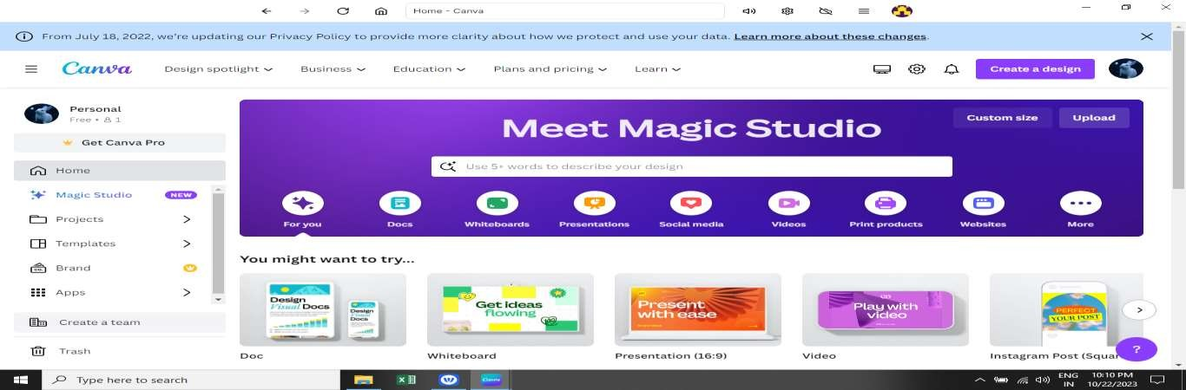

Navigation



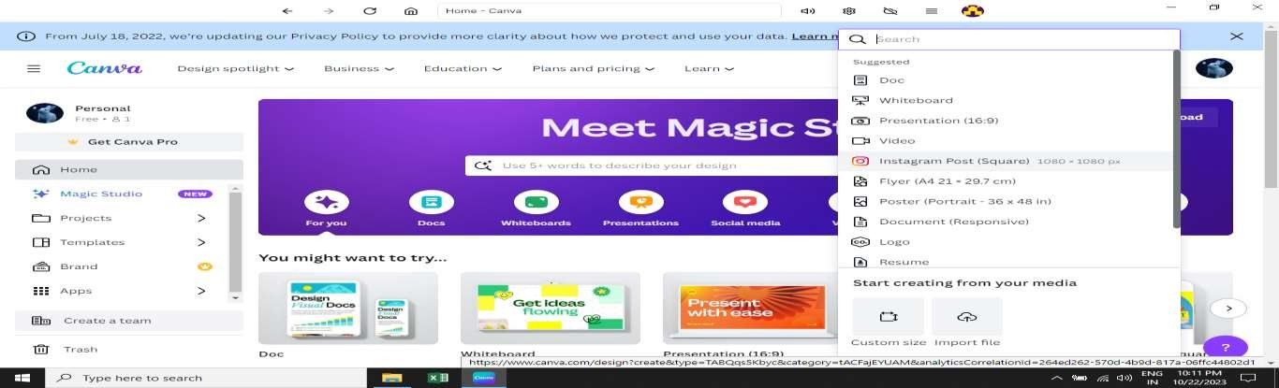

Choose any format



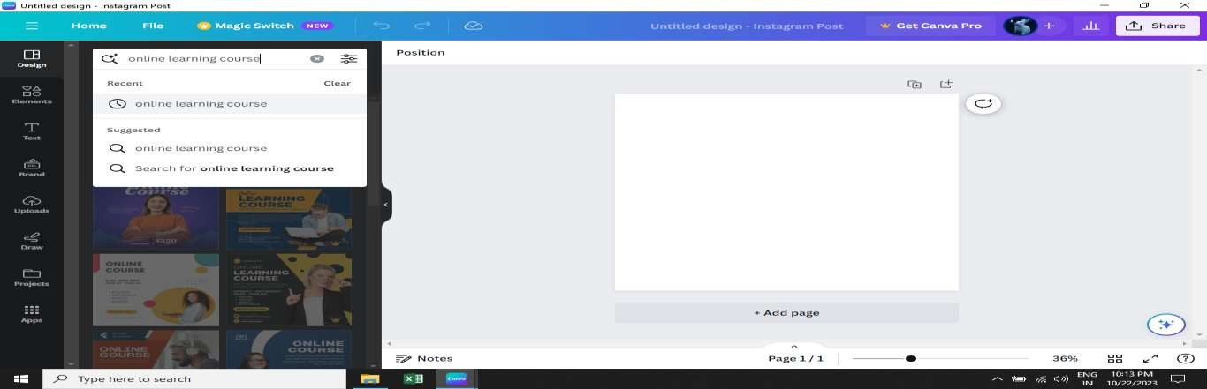

Create Design



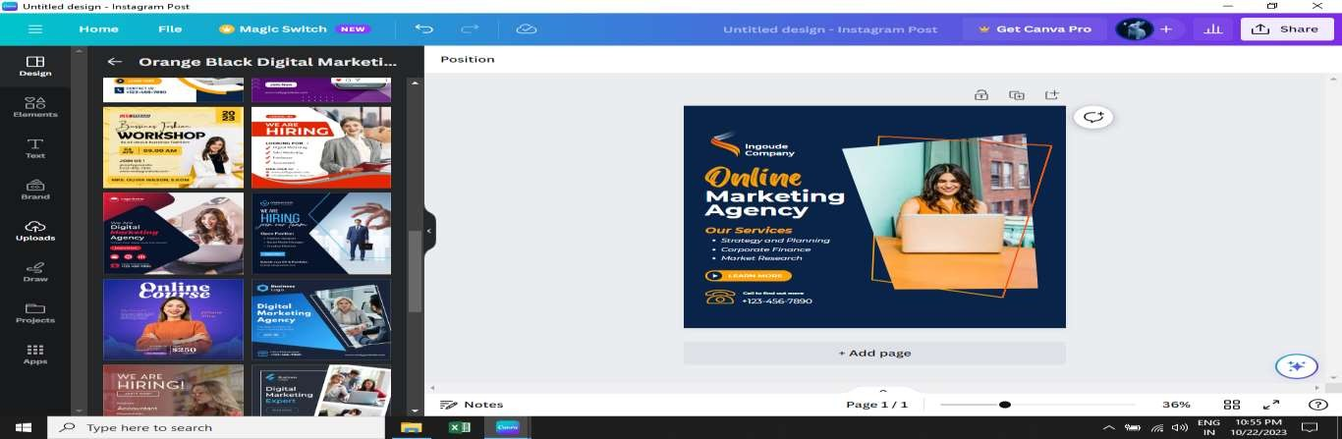

Choose template



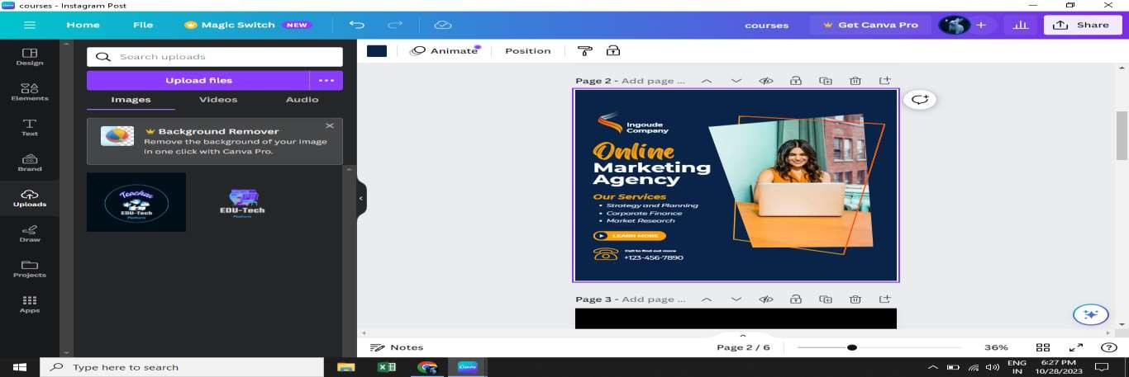

Click “uploads”



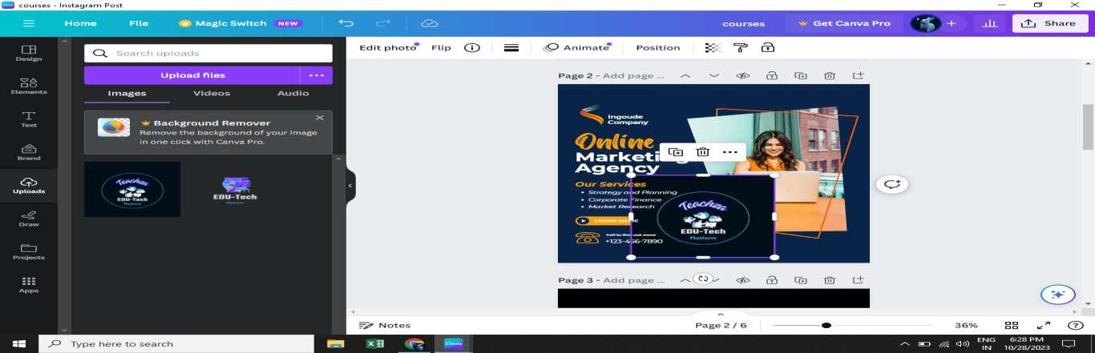

Upload logo



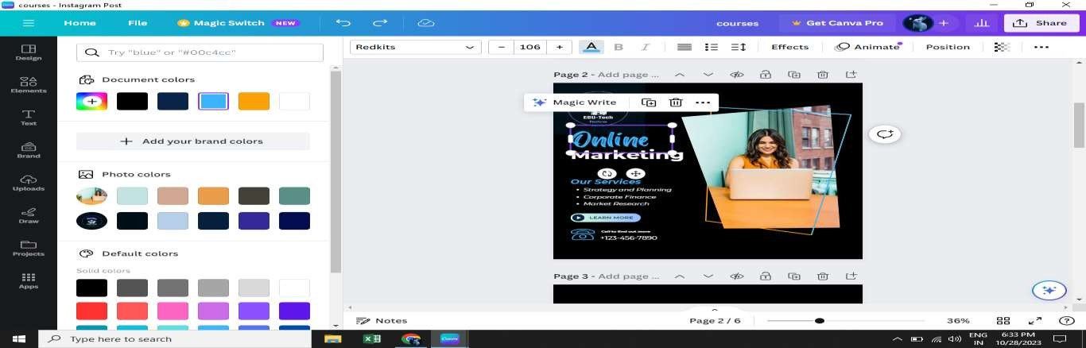

Change text colors



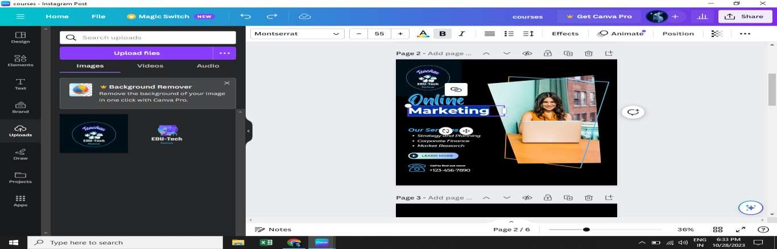

Edit text Content



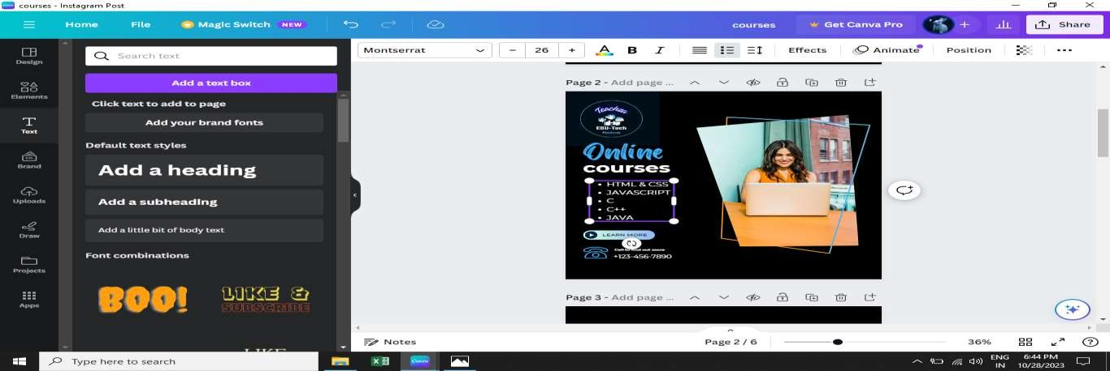

Add Text Box



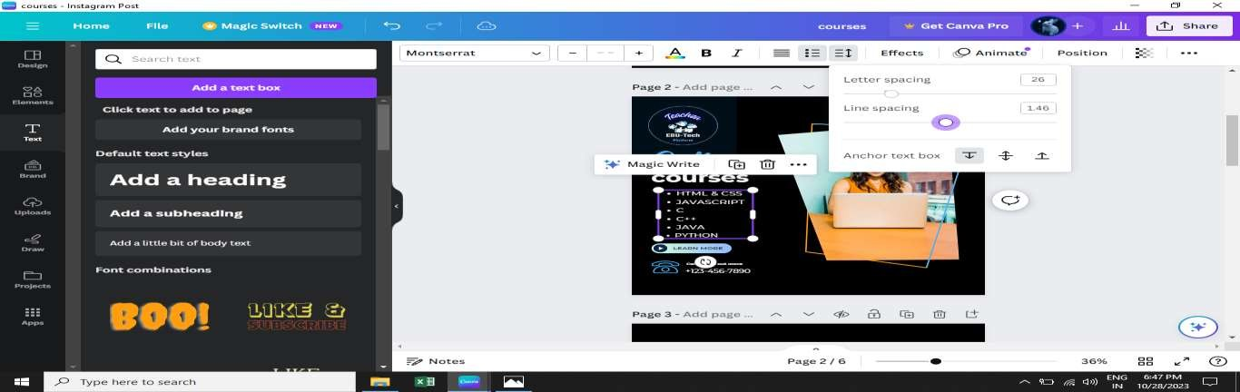

Line spacing & Letter Spacing



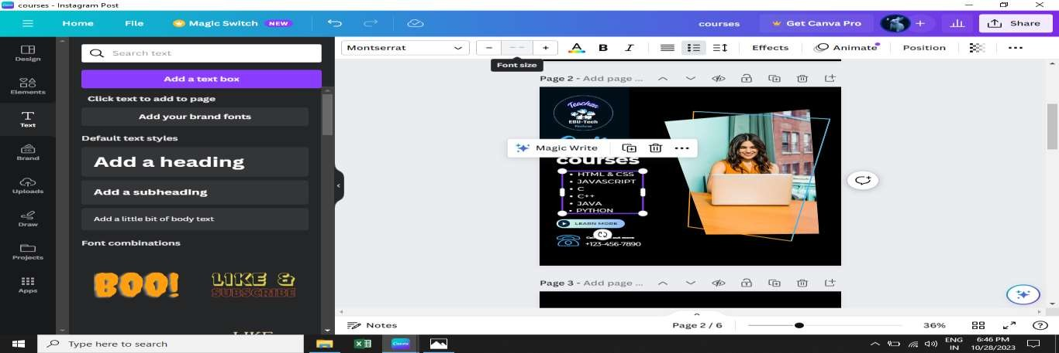

Font size



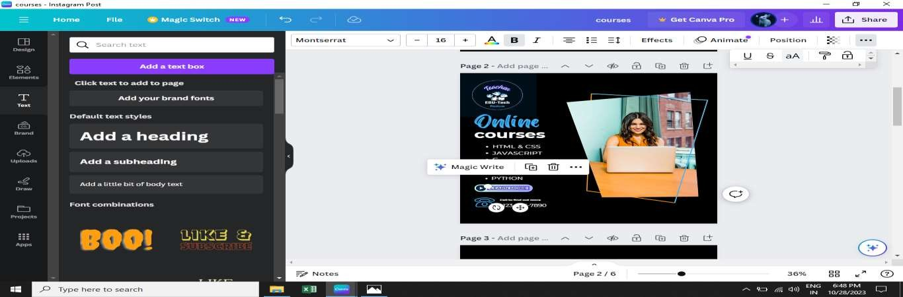

Upper case & Lower case



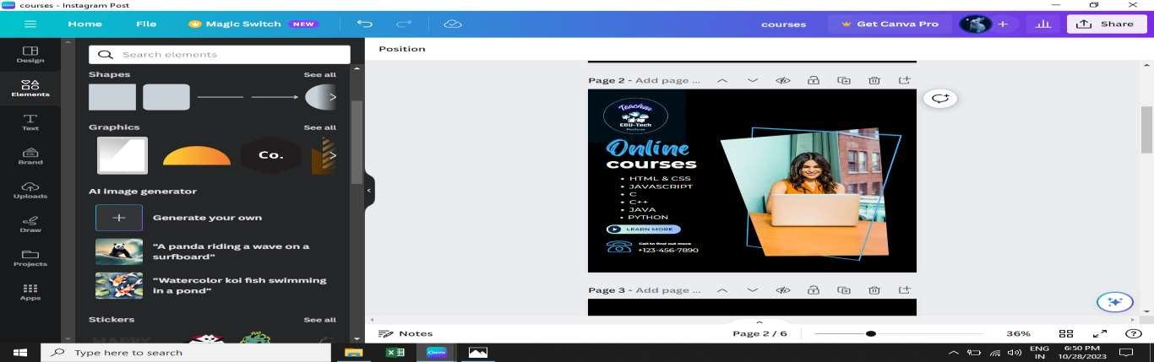

Click – Elements icon



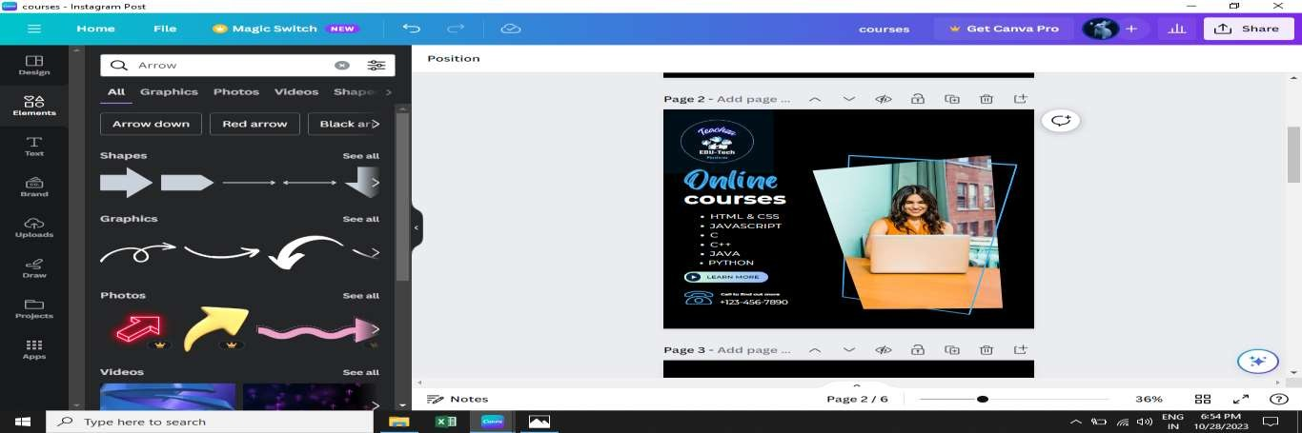

Search Elements



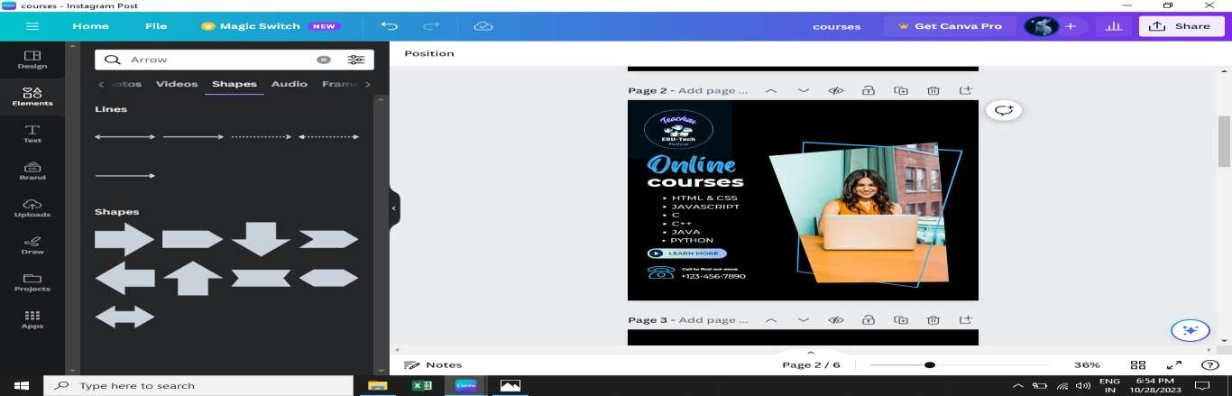

Click See all elements



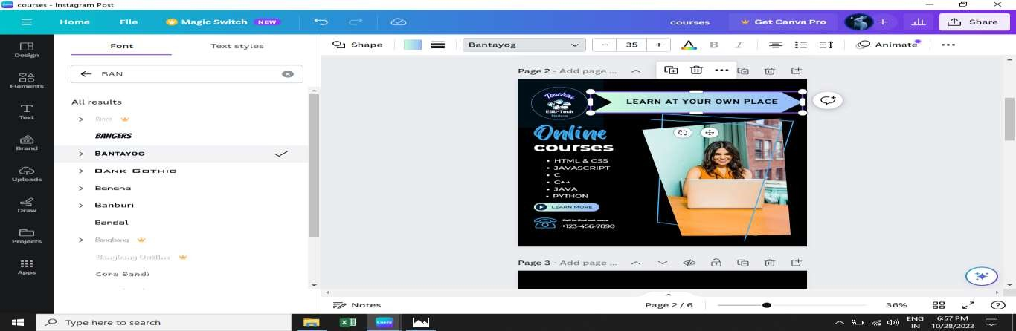

Add own content & Change Font Style



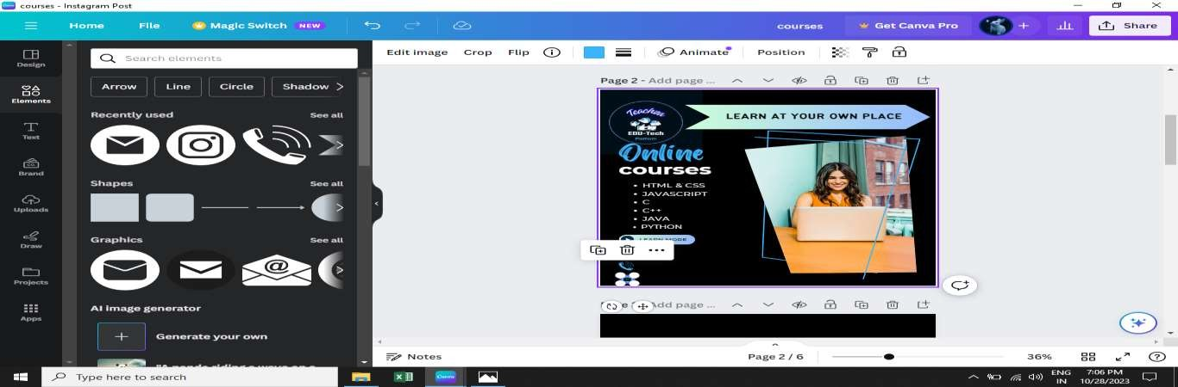

Add more Graphic Elements



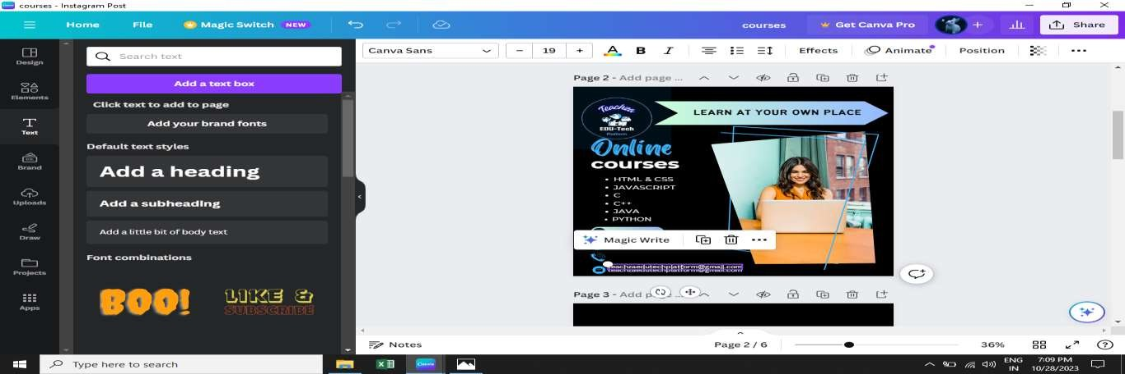

Click Duplicate icon



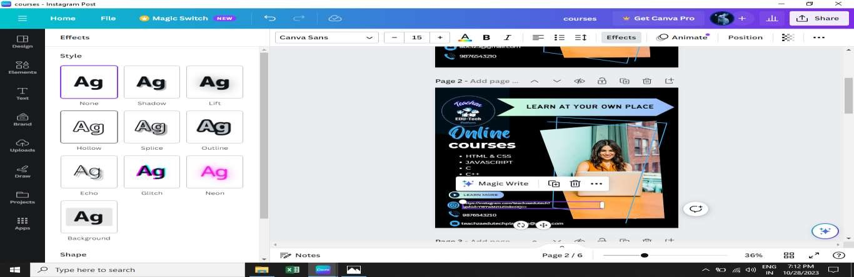

Text Effect



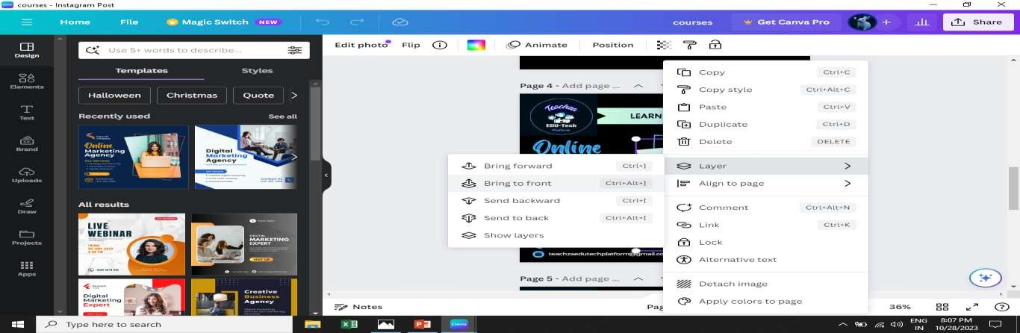

Layer



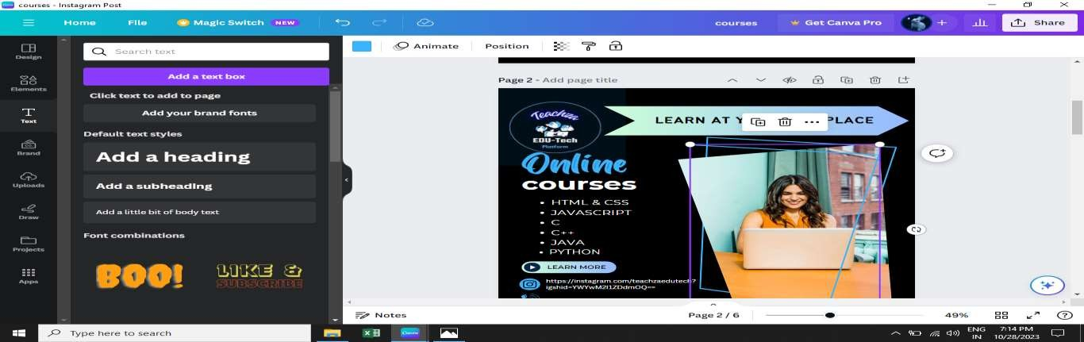

Adjust Length



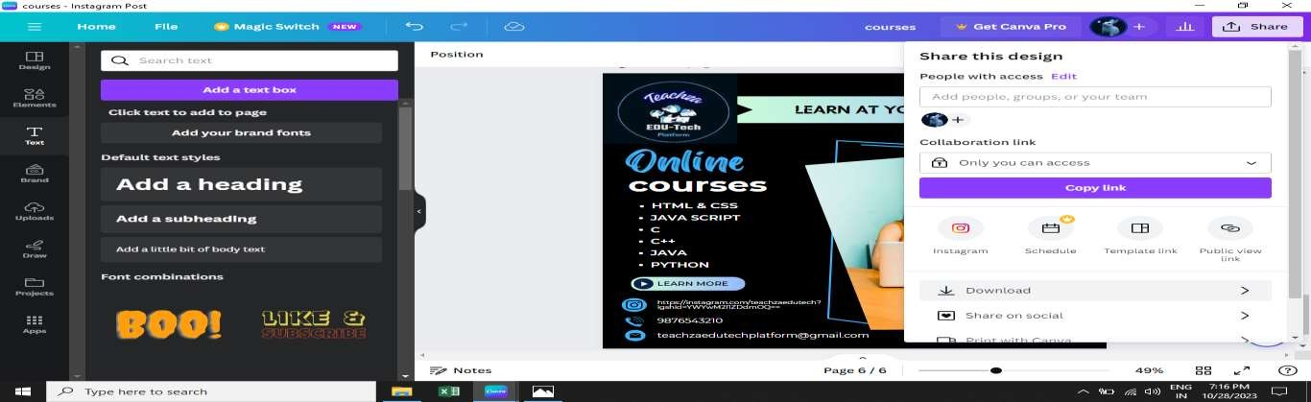

Click Share Icon



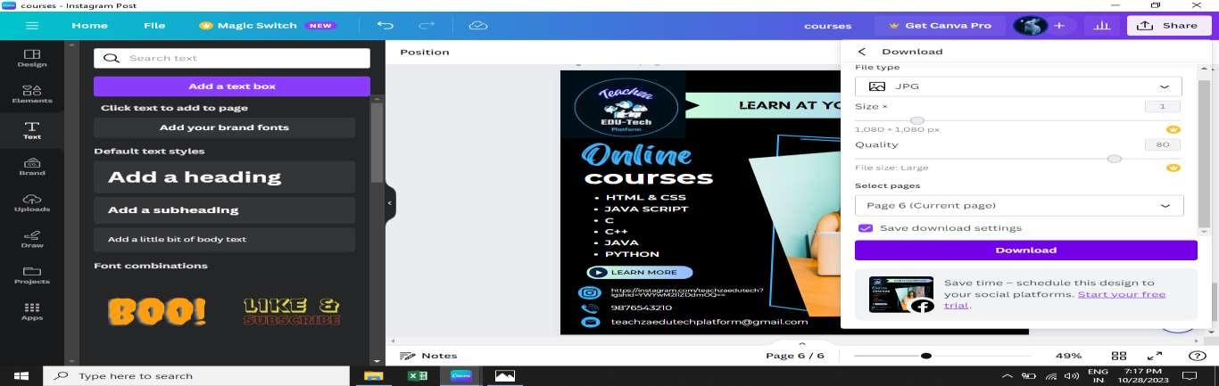

Click Download





Final Design : Sponsored post for Instagram